Clark College Recreation
Ridgefield Kayak
October 10th , 2014
3:0pm- 5:00pm

Never been in a kayak before? Paddling since the day you were born? This event is for you! Come out for a relaxing paddle of the Ridgefield National Wildlife Refuge shoreline!
Ridgefield Kayak
Surround yourself with the beauty of the 5,150 acre Wildlife Refuge as you paddle through calm water trails that support all levels of kayaking. You can choose between single or tandem (2 person) kayaks and all of your gear is included!
- $7 payment at cashiers due by Oct. 6. Present receipt to Garet Studer (OSC 141) to reserve and guarantee your spot. 20 person max, spaces go fast, register today!
- Ridgefield Kayak is located at:
  - McCuddy’s Marina Five Mill Street
Ridgefield, WA 98642
- Meet at McCuddy’s Marina at 2:15pm to get checked in!
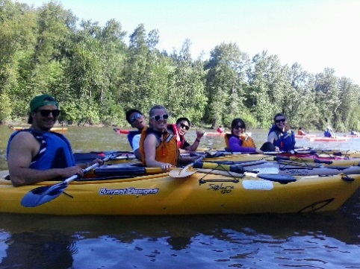 | 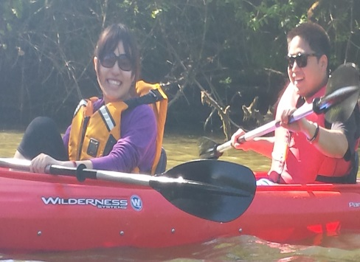

Phone: Clark Intramural Office: (360) 992-2185
Ridgefield Kayak: (360) 727-4520

Email: gstuder@clark.edu

